**Course Methods Year 12 test one 2022**

Student name: ________________ Teacher name: ________________

**Task type: Response**

**Time allowed for this task: _____40______ mins**

**Number of questions: ____8_______**

**Materials required: No calculators nor classpads allowed**

Standard items: Pens (blue/black preferred), pencils (including coloured), sharpener, correction fluid/tape, eraser, ruler, highlighters

Special items: Drawing instruments, templates, **NO notes**.

**Marks available: ___40___ marks**

**Task weighting: _10___%**

**Formula sheet provided: Yes**

**Note: All part questions worth more than 2 marks require working to obtain full marks.**

Q1 (3, 4 & 3 = 10 marks)

Differentiate the following:

1. 
2.  and **simplify**
3.  do **not** simplify

Q2 (4 marks)

Determine the equation of the tangent to  at 

Q3 (5 marks)

Determine the coordinates of the stationary points and their nature for . Justify.

Q4 (3 marks)

The displacement of a body from an origin O, at time  seconds, is  metres where



Determine the velocity and the displacement of the body when the acceleration is zero.

Q5 (4 marks)

Consider the function  which is graphed below.

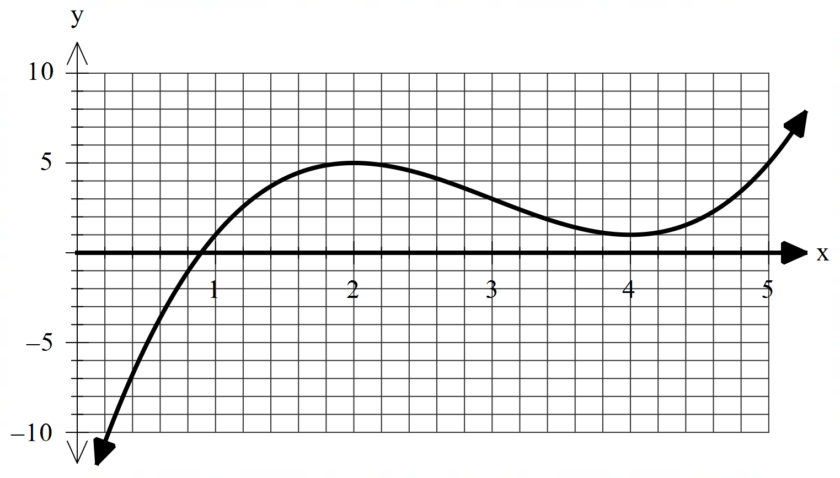

On the **axes below**, sketch the gradient function  indicating on your sketch the location of any stationary points and any inflection points for . (labelled)

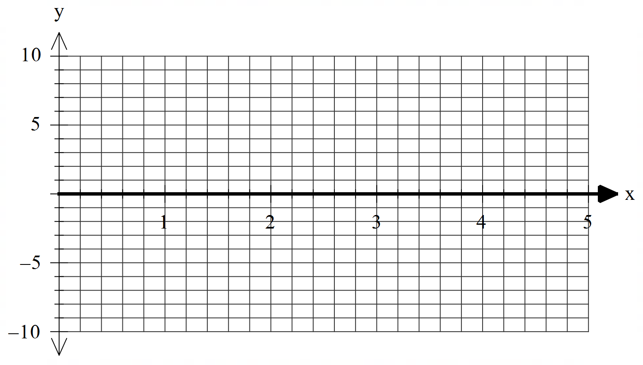

Q6 (2 & 3 = 5 marks)

Consider the function  where .

1. Using the increments formula (small change) determine an approximate value for .
2. The volume of a sphere of radius  metres is given by . Using the increments formula determine the approximate percentage change in volume for a 3% change in the radius.

Q7 (4 marks)

Let  equal the number of hectares that a farmer will use to grow corn one season. The amount of corn to be harvested per hectare is given by  kg for  . **Using calculus** determine the number of hectares that should be used to maximise the amount of corn produced.

Q8 (5 marks)

Let the cost, $, to make  items in a factory be given by  dollars. Using calculus show that the minimum **average cost** per item is equal to the marginal cost at this number of items.